Department of Iron Metallurgy
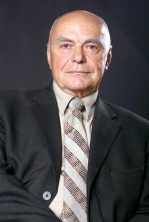
Department manager: Arkadij Konstantinovich Tarakanov
Contacts:
Address Department of Iron Metallurgy, 4 Gagarina avenue, Dnipropetrovsk, Ukraine, 49600
E-mail: kaf.chugun@metal.nmetau.edu.ua
Phone: (+38056) 3748229
Alternative homepage: https://www.facebook.com/kaf.chugun/

The department was established in 1899. This event coincided with the opening of the High Mining School in Ekaterinoslav that specializes in the training of mining engineers. Among the founders of the department were most authoritative blast-furnace specialists and scientists, namely academician M. A. Pavlov and full professor P.G. Rubin. The department has become a progenitor of many other departments of the modern National metallurgical academy of Ukraine.
The teaching staff of the Department is presented by 3 full professors, Doctor of Science, 3 assoociate professors, Candidate of Science.
At present time the department trains bachelors, specialists and masters in a field of knowledge "Metallurgy and matetriality" on a direction "Metallurgy" in groups:
- Iron metallurgy;
- Agglomeration of metallurgical row materials.

